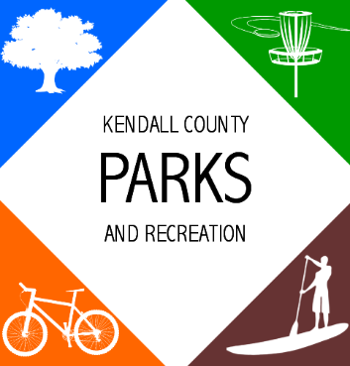
AGENDA
Parks Advisory Board Meeting
11:00 AM- July 22, 2021

Ring Mountain Event Center
716 FM 289 Comfort, TX 78013

- Call to Order
- Public Comments
- Approval of Minutes
- Adoption of Minutes
Parks Advisory Board- June 24, 2021- Minutes
- Announcements/Reminders
- Daniel Vetter is inviting you to a scheduled Zoom meeting.

Topic: Zoom Meeting
Time: Jul 22, 2021 11:00 AM Central Time (US and Canada)

Join Zoom Meeting
https://us06web.zoom.us/j/85324692962

Meeting ID: 853 2469 2962
One tap mobile
+13462487799,,85324692962# US (Houston)
+12532158782,,85324692962# US (Tacoma)

Dial by your location
+1 346 248 7799 US (Houston)
+1 253 215 8782 US (Tacoma)
+1 720 707 2699 US (Denver)
+1 312 626 6799 US (Chicago)
+1 646 558 8656 US (New York)
+1 301 715 8592 US (Washington DC)
Meeting ID: 853 2469 2962
Find your local number: https://us06web.zoom.us/u/kgnWv43Rg

- Special Called Meeting- Workshop for Commissioners Court to meet newly formed Parks Advisory Board members and discuss the board’s goals.

- Consideration and Action

- Schedule next advisory board meeting

- Staff Reports

- Traffic Counts

- Comfort Park Maintenance Agreement

- Other Business

- Presentation by Gary Louie from the Comfort Area Foundation

- Future Agenda Items

- Parks Advisory Board group discussion topics

- Adjournment

